If you want to check admission controllers in your cluster you can do it as follows:

* Kind:
  + Create your cluster:

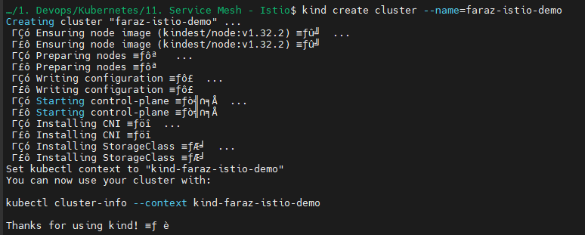

* + kubectl get nodes
  + kubectl get pods -n kube-system

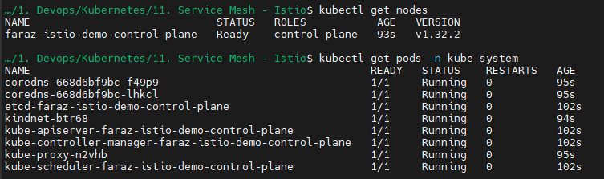

* + docker exec -it faraz-istio-demo-control-plane bash
    - cat /etc/kubernetes/manifests/kube-apiserver.yaml

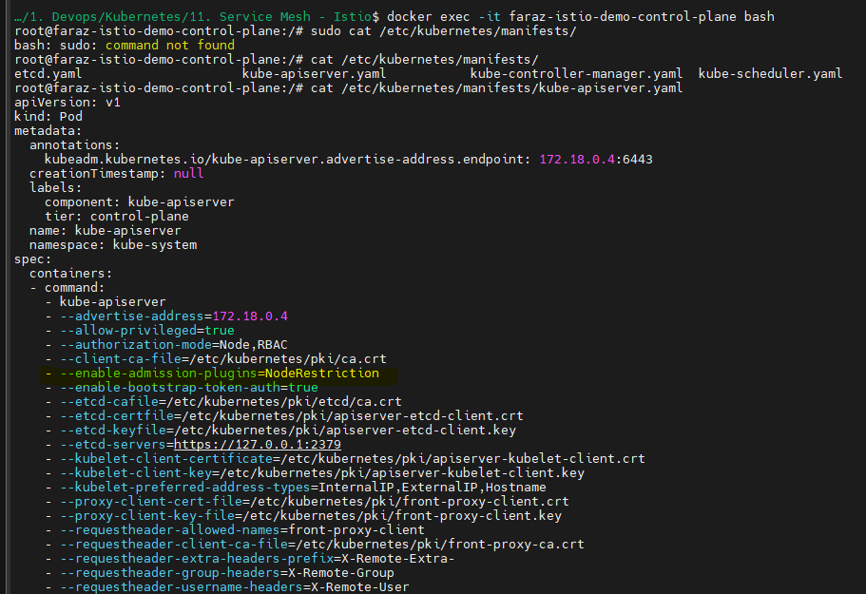

* Minikube:
  + minikube ssh
  + cd /etc/kubernetes/manifests/
  + sudo cat kube-apiserver.yaml

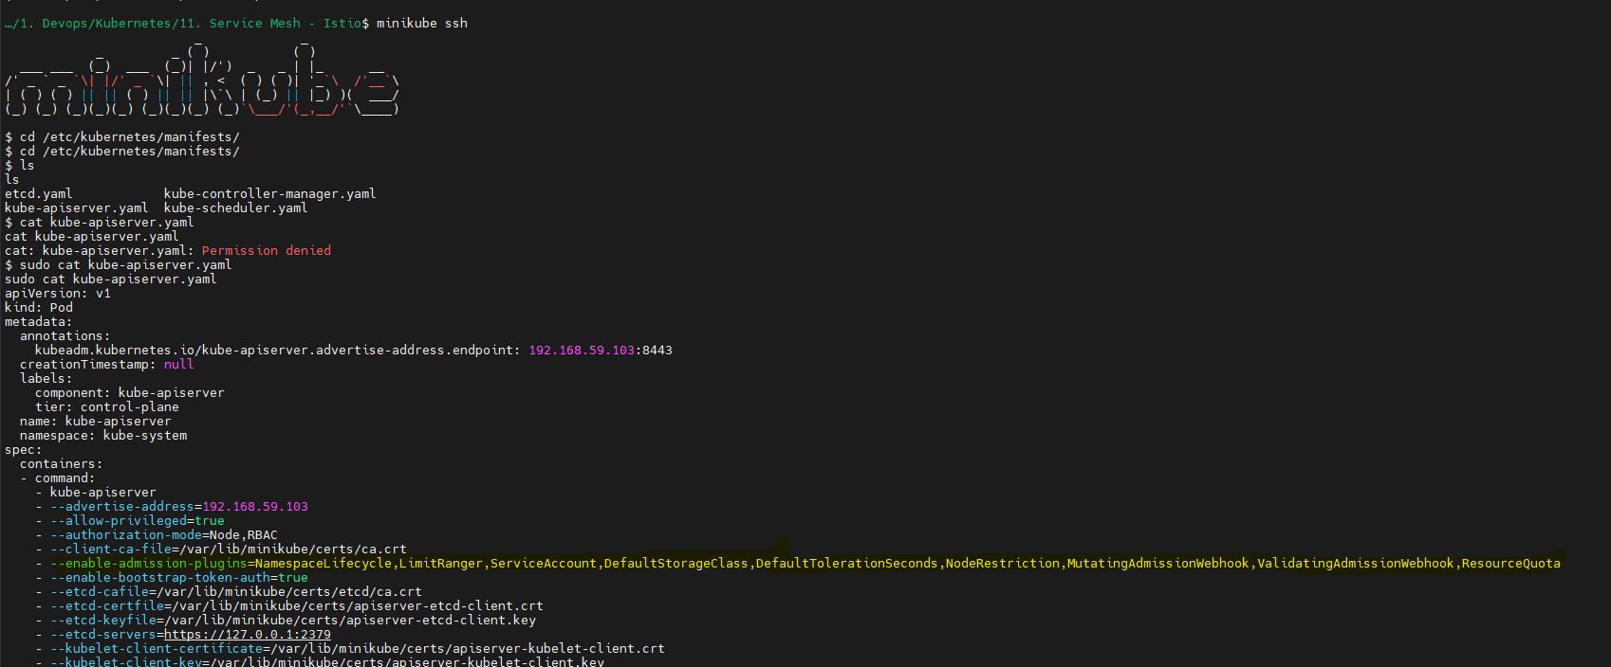

Let’s validate the Default Storage class admission controller:

I am not providing the storage class in my PVC:

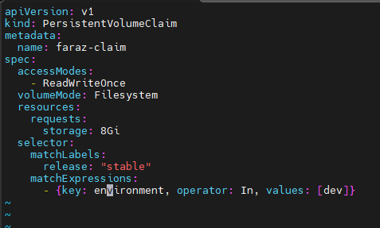

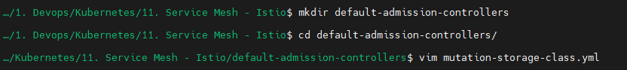

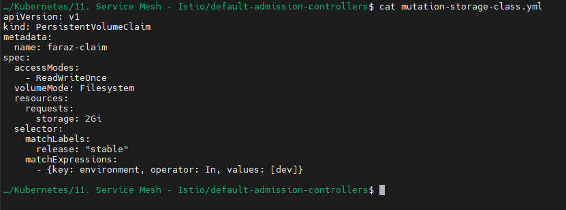

* kubectl apply -f mutation-storage-class.yml



* kubectl edit pvc faraz-claim

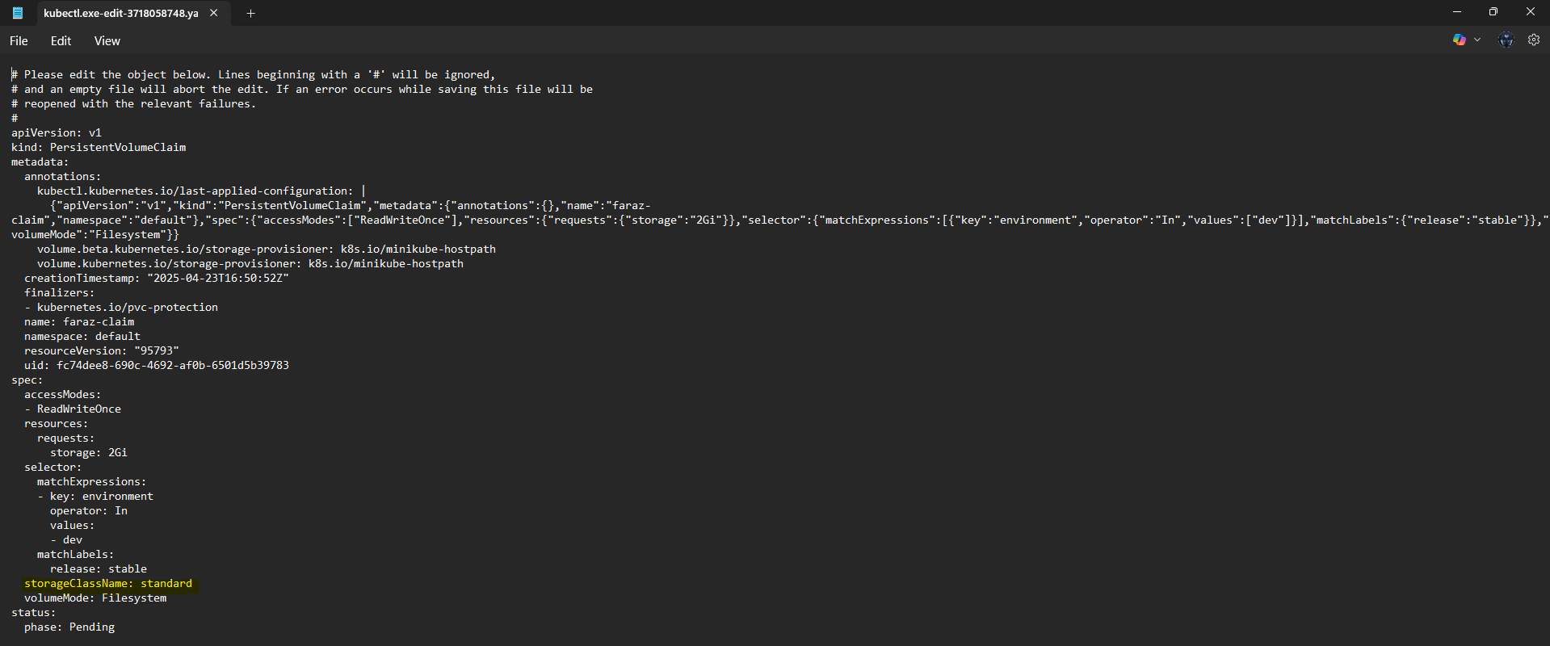

Here you will be able to observe the admission controller mutated my request as DefaultStorageClass admission controller was enabled.

You can also verify the validation admission controller:

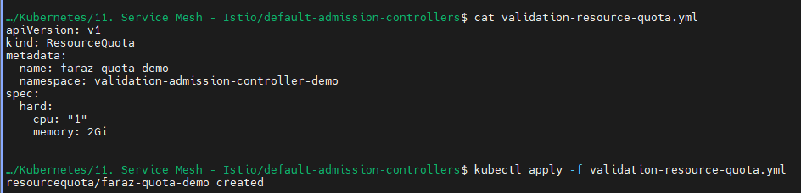

Here, I have set the resource quota for CPU as 1 and Memory of 2 GB



Now when I try to run a pod with memory of 3 GB

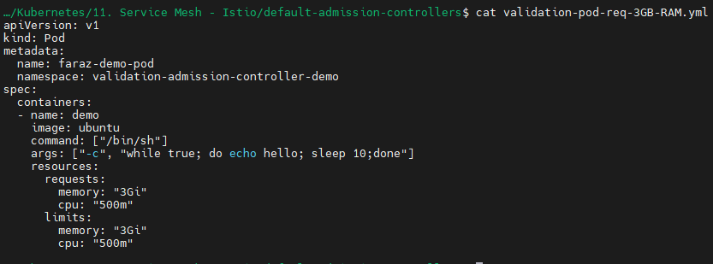

The ResourceQuota admission controller will validate and will intercept my request:



User Request -> API server

-> Authorization and authentication the request -> Validate/Mutate -> ETCD